Title: Cornballer - A novel kitchen appliance for cooking corn balls

Abstract: The present invention relates to a novel kitchen appliance designed to cook corn balls quickly and efficiently. The Cornballer is a compact, portable device that can be easily transported and stored when not in use. The device features an easy-to-use control panel that allows users to adjust the cooking time and temperature to achieve the perfect corn ball consistency.

Background of the Invention: The idea for the Cornballer was inspired by the need for a more efficient and user-friendly way to cook corn balls. Traditional cooking methods, such as using a deep fryer or baking in an oven, can be time-consuming and messy. The Cornballer solves this problem by providing a quick and easy way to cook corn balls at home.

Description of the Invention: The Cornballer is designed to cook corn balls evenly and quickly, without the need for oil or other cooking additives. The device features a non-stick cooking surface that prevents the corn balls from sticking and burning. The Cornballer also has a built-in timer and temperature control, allowing users to customize the cooking process to their liking.

Claims:

1. A kitchen appliance for cooking corn balls, comprising:

a. a heating element for heating a cooking surface;

b. a cooking surface, comprising a non-stick material;

c. a timer and temperature control interface for controlling the cooking time and temperature;

d. a power cord for supplying electrical power to the appliance.

2. The kitchen appliance of claim 1, wherein the cooking surface is removable for easy cleaning.

3. The kitchen appliance of claim 1, further comprising a safety mechanism to prevent overheating.

4. The kitchen appliance of claim 1, wherein the timer and temperature control interface is digital.

5. The kitchen appliance of claim 1, wherein the cooking surface is circular in shape.

6. The kitchen appliance of claim 1, further comprising a lid for trapping heat during the cooking process.

Conclusion: The Cornballer represents an innovative solution to the problem of how to cook corn balls quickly and efficiently. Its compact size and easy-to-use controls make it a valuable addition to any kitchen. We believe that the Cornballer has significant commercial potential and look forward to bringing this product to market.

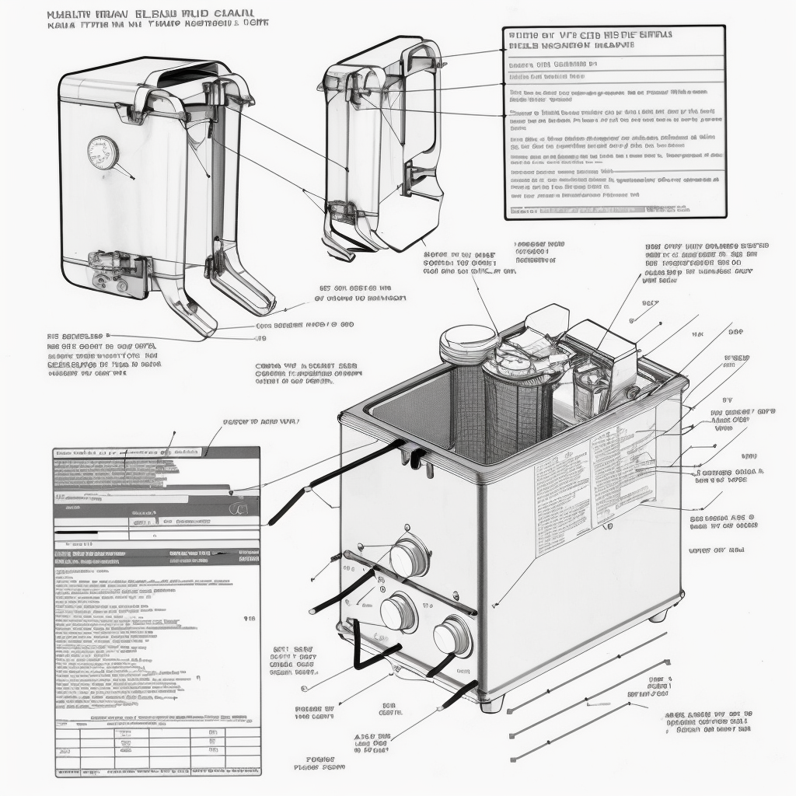

Cornballer diagram